**E-Book Shopping**

**Use Case Document**

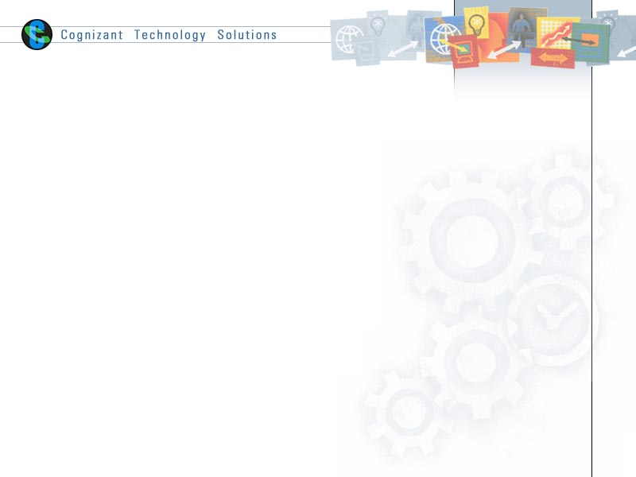

|  |  |  |  |
| --- | --- | --- | --- |
|  | Prepared By / Last Updated By | Reviewed by | Approved By |
| Name | Amitoj Wadhera, Nimit Gupta, Mohit Arora, Monika Choudhary | Mr. Abhinandan | Mrs. Shilpa Mahajan |
| Role | Team Member | Mentor | Academy Head |
| Signature |  |  |  |
| Date |  |  |  |

Table of Contents

1.0 Introduction

1.1 Purpose & Scope of the document

1.2 Intended Audience

1.3 Use case ‘User Registration’

1.3.1 Use case attributes

1.3.2 Business Rules

1.3.3 UI Requirements

1.3.4 UI Field Validations

1.4 Use case ‘Login Page’

1.4.1 Use case attributes

1.4.2 Business Rules

1.4.3 UI Requirements

1.4.3 UI Field Validations

1.5 Use case ‘User Home Page’

1.5.1 Use case attributes

1.5.2 Business Rules

1.5.3 UI Requirements

1.6 Use case ‘Cart Page”

1.6.1 Use case attributes

1.6.2 Business Rules

1.6.3 UI Requirements

1.7 Use case ‘Payment Page’

1.7.1 Use case attributes

1.7.2 Business Rules

1.7.3 UI Requirements

1.7.4 UI Field Validations

1.8 Use case ‘Admin Homepage’

1.8.1 Use case attributes

1.8.2 Business Rules

1.8.3 UI Requirements

1.8.4 UI Field Validations

2.0 Database Design

2.1 Tables Structure

3.0 Data Flow Diagram

# Introduction

## Purpose & Scope of the document

The purpose of this Use case document is to systematically capture requirements for the project and the system to be developed in terms of use cases. Functional use cases are captured in this document. It also serves as the input for the project scoping.

The scope of this document is limited to addressing the use cases from a user, quality, and non-functional perspective.

## Intended Audience

Each member of the project team

## Use case ‘User Registration’

### Use case attributes

**Use Case Description:**

This use case deals with the capture of user details. The ‘user’ here will be the operator of the system and will be keying in the user details.

**Scope:**

* User registration

**Actors:**

* User – the operator

**Trigger:**

Click ‘Create Account’ button in the ‘User Registration’ page

**Pre-Condition:**

User get redirected to the ‘User Registration’ page upon click of ‘Create Account’ link on the login page.

**Post Condition:**

User is in the registration page & submit details.

**Flow of Events:**

User at login page 🡪 Click ‘Create Account’ link 🡪 User is in the registration page 🡪 User details are submitted and added to the database.

**Primary Scenario:**

A new user – is able to click ‘Create Account’ link and able to provide his details and get registered in the system.

### Business Rules

Business rules should be defined using the following attributes: -

* When the user clicks on the ‘Create Account’ link, it should re-direct to registration form.
  + - User needs to fill some of the basic attributes/fields as mentioned below in requirement: First Name, Last Name, Age, Gender, Contact Number, E-Mail Id, Password.
* Clicking ‘Create Account’ should validate the datatype constraints for each field.
* Post-successful field level validation, save the information in the database
* Upon saving the information in the database, redirect to login page.

### UI Requirements

Here is a prototype on how the ‘User Registration’ page should look like.

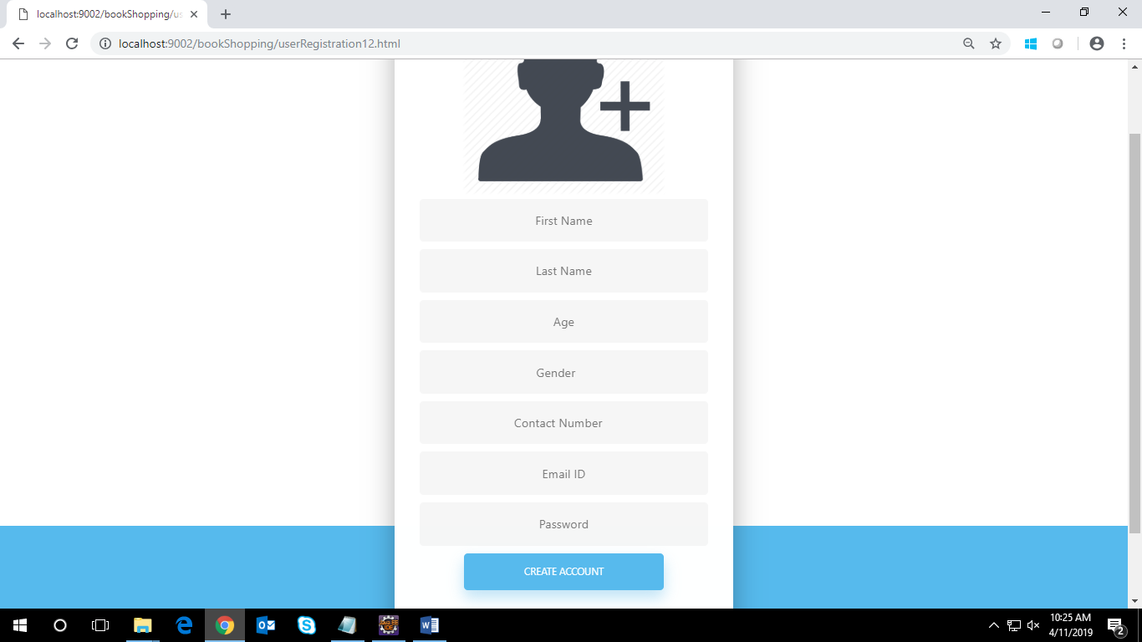

### UI Field Validations

Please refer to the below requirements for field level validations:

* All fields are mandatory.
* The Email ID format must be checked.
* Gender should be chosen from the dropdown options.

## Use case ‘Login Page’

### Use case attributes

**Use Case Description:**

This use case deals with the authentication of the user/admin credentials. The ‘user’/ ‘admin’ here will be the operator of the system and will be keying in the user/admin information into the system.

**Scope:**

* User/admin credentials authentication

**Actors:**

User – the operator/ Admin – the operator

**Trigger:**

Click ‘Login’ link, after keying in ‘Username’ & ‘Password’ field.

**Pre-Condition:**

User/Admin being able to access the login page.

**Post Condition:**

User/Admin is in the respective user/admin home page.

**Flow of Events:**

User at login page 🡪 Key in ‘Username’ & ‘Password’ field 🡪 User credentials are validated 🡪 Respective user/admin home page is displayed.

**Primary Scenario:**

A registered user/admin is able to click ‘Login’ link, after keying in ‘Username’ & ‘Password’ field and get his credentials authenticated with the existing database entry.

**Alternative Scenario:**

A registered user/admin is able to click ‘Login’ link, after keying in ‘Username’ & ‘Password’ field and unable to get his credentials authenticated. The user is redirected to login page for an invalid username or password.

### Business Rules

Business rules should be defined using the following attributes: -

* A registered user/admin is able to click ‘Login’ link, after keying in ‘Username’’ & ‘Password’ field and get his credentials authenticated with the existing database entry.

### UI Requirements

Here is a prototype on how the Login Page should look like.

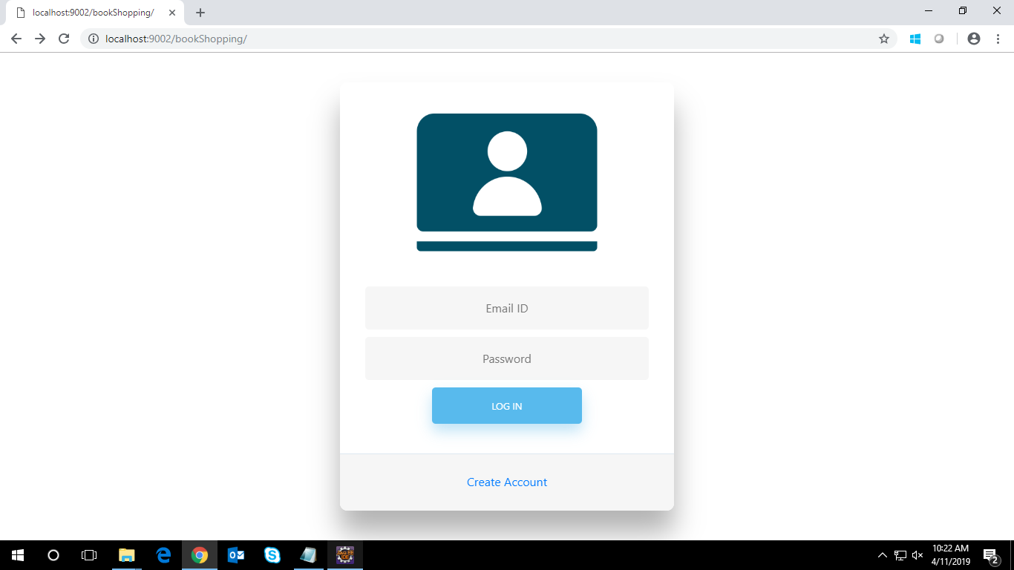

### UI Field Validations

Please refer to the below requirements for field level validations:

* All fields are mandatory.
* The Email ID format must be checked.

## Use case ‘User Home Page’

### Use case attributes

**Use Case Description:**

This use case deals with the display of books and their details. The ‘user’ here will be the operator of the system and will be either searching a particular book or adding required number of books to the cart.

**Scope:**

* Adding book to the cart for purchase.

**Actors:**

* User – the operator

**Trigger:**

User should get redirected to the Cart Page upon clicking on the cart icon in user

homepage.

**Pre-Condition:**

User should be able to get redirected to the ‘User Home Page’ upon clicking the login button on the login page.

**Post Condition:**

User is in the User home page & add book to the cart.

**Flow of Events:**

User at Login Page🡪click ‘Login’ button🡪User at user homepage 🡪click book name 🡪book details will be displayed 🡪 Click ‘Add to cart’ button for required book🡪 added to database🡪’book added’ message will appear 🡪 Click ‘cart’ icon

**Primary Scenario:**

User is able to see details of book and able to add required number of books in the shopping cart by clicking ‘Add to cart’ button. User is also able to search for particular required book.

### Business Rules

Business rules should be defined using the following attributes: -

* When the user clicks on the book name, it should re-direct to page showing full details of book.
* Details of book is mentioned below in requirement: CAT Name, Book Id, Book Name, Book Price, Availability, Binding, Language, Author Name, Publisher Name, Delivery Date.
* User is able to search the required book in home page using search button.
* Clicking ‘Add to cart’ should add the book to the cart page and ‘book added’ message is displayed.
* Post-successful addition of book to cart, save the information in the database.

### UI Requirements

Here is a prototype on how the user home page should look like.

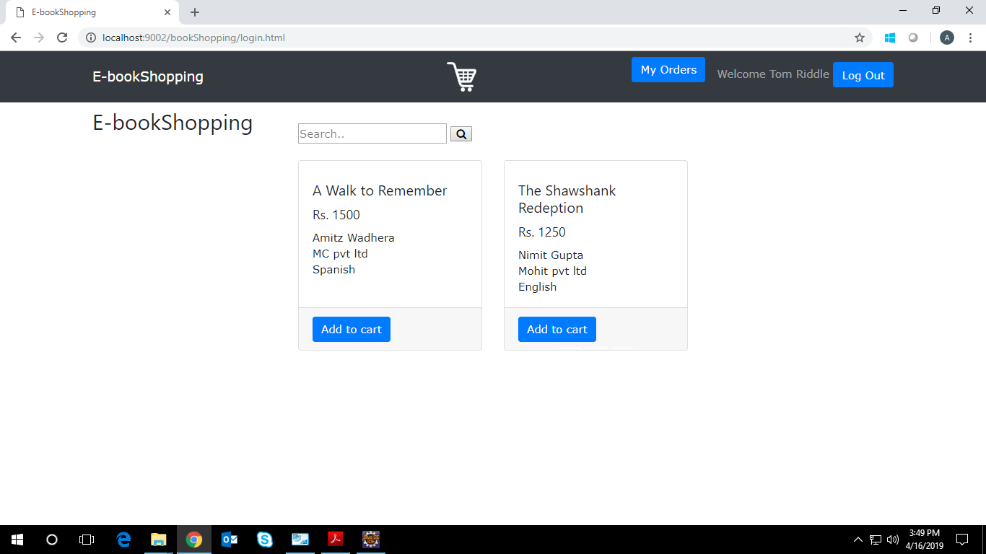

## Use case ‘Cart Page’

### Use case attributes

**Use Case Description:**

This use case deals with the ability to display books of ‘User Home Page’ selected by user to be purchased. The ‘user’ here shall be the operator of the system and will be managing the quantity of books that are added to the cart and display the price according to it. The ‘User’ can remove added books if required and finally checkout with final price.

**Scope:**

View, remove and checkout books added in the cart**.**

**Actors:**

* User – the operator

**Trigger:**

Click ‘Checkout’ button in the ‘Cart’ page

**Pre-Condition:**

User should be able to get redirected to the ‘Cart’ upon clicking the cart icon on the user home page.

**Post Condition:**

User is displayed a page showing all the added books and after checking out with required quantities and final price, it will redirect to ‘Payment Page’.

**Flow of Events:**

User at login page 🡪 Click ‘Login’ button 🡪 User at homepage ->Books are added to cart 🡪 Click the cart icon 🡪 Page is displayed with added books🡪quantity and price is managed🡪click ‘checkout’ button🡪User is redirected to ‘Payment’ page.

**Primary Scenario:**

A user – is able to view added books in the cart and manage their price according to required quantity. User can also remove any book if not required. The final bill will be generated and user will checkout and redirect to payment page

### Business Rules

Business rules should be defined using the following attributes: -

* When the user clicks on added book image, it will show remove option and can be removed from cart if not required.
  + - User can manage the quantity of books and will display the price according to it.
    - User will get final price and on clicking ‘checkout’ will redirect to ‘payment page’.

### UI Requirements

Here is a prototype on how the ‘Cart” page should look like.

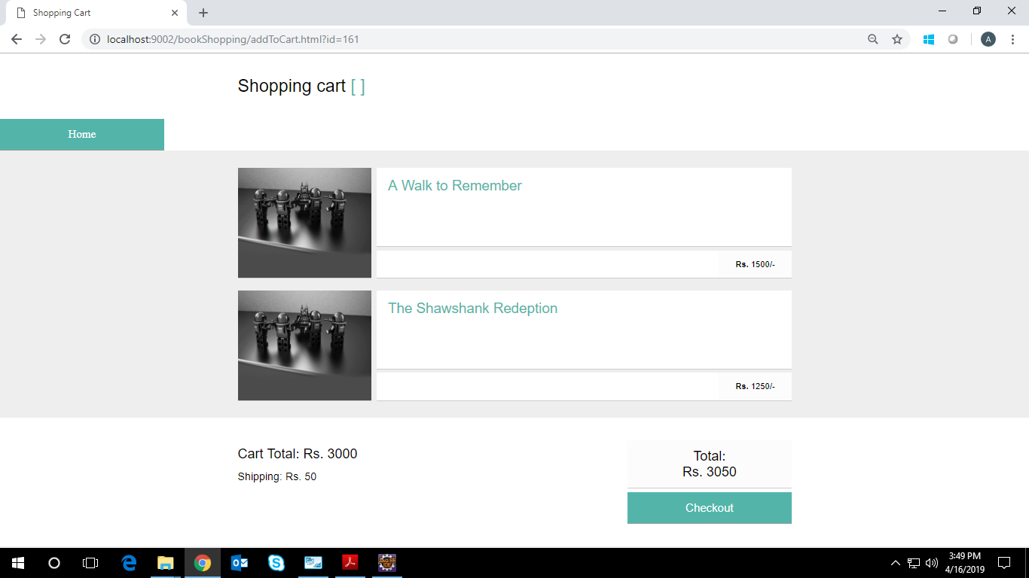

## Use case ‘Payment Page’

### Use case attributes

**Use Case Description:**

This use case deals with the ability of the user to pay the bill listed against the order. The ‘user’ here shall be the operator of the system and will be keying in the bill payment details.

**Scope:** Bill Payment

**Actors:**

* User – the operator

**Trigger:**

Click ‘Checkout’ button in the page.

**Pre-Condition:**

User being able to access the cart & get redirected to the ‘payment’ page upon clicking against ‘checkout’ button.

**Post Condition:**

User is in the payment page & after filling payment credentials, pays the bill by clicking on ‘checkout’ button.

**Flow of Events:**

User at login page 🡪 Click ‘login’ button 🡪 User at home page->books added to cart

🡪manage quantity and price of book🡪 Click ‘checkout’ button->User at payment page🡪 fill payment credentials🡪Click ‘checkout’ button 🡪 Message of successful or unsuccessful order is displayed.

**Primary Scenario:**

A user – is able to fill all valid payment credentials and click ‘checkout’ button for successful order.

**Business Rules:**

Business rules should be defined using the following attributes: -

* + - User needs to fill all valid payment credentials.
* Details of payment is mentioned below in requirement: Full Name, Email, Address, City, State, Zip Code, Accepted cards, Name on Card, Card Number, Exp month, Exp year and CVV.
* Post-successful payment, the corresponding entries are saved to the database.
* Thereafter message of successful or unsuccessful order will be displayed.

### UI Requirements

Here is a prototype of Payment Page with checkout button -

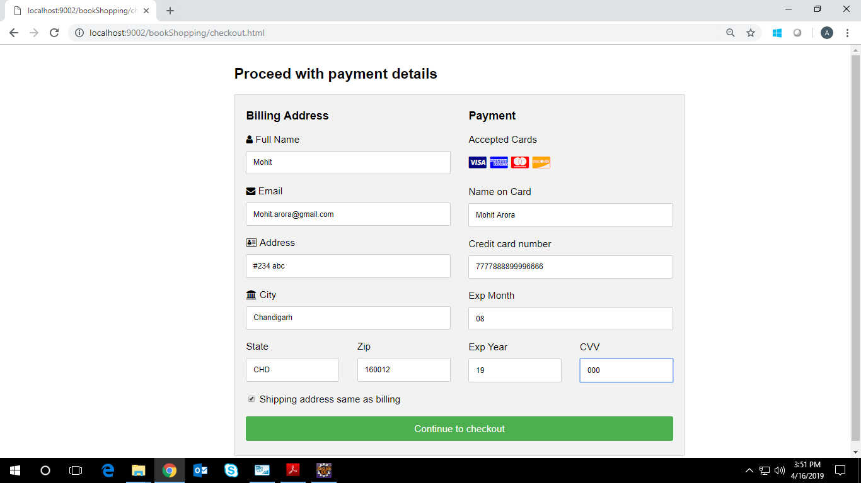

### UI Field Validations

Please refer to the below requirements for field level validations:

* All fields are mandatory.
* The Email ID format must be checked.
* Credit Card Number should not be more than 16 digits.

## Use case ‘Admin Home Page’

### Use case attributes

**Use Case Description:**

This use case deals with the management of books available. The ‘admin’ here will be the operator of the system and will be either adding the book or viewing or removing the book.

**Scope:**

* Adding new books to the database for user as well as view and removal of books.

**Actors:**

* Admin– the operator

**Trigger:**

Click ‘add book’ or ‘view/remove’ in Admin home page.

**Pre-Condition:**

User should be able to get redirected to the ‘Admin Home Page’ upon clicking the login button on the admin login page.

**Post Condition:**

Admin is in the Admin home page & add or view or remove book to the database.

**Flow of Events:**

Admin at admin login page🡪click ‘login’ button🡪admin redirected to admin home page🡪

Click ‘add book’ link🡪fill all book details🡪click ‘add book’ button to add new book.

Admin at admin login page🡪click ‘login’ button🡪admin redirected to admin home page🡪

Click ‘view/remove’ link🡪view or delete book details🡪redirected to admin home page again.

**Primary Scenario:**

Admin – is able to add details of book as well as view or remove book from the available list.

Here is a prototype on how the admin home page should look like.

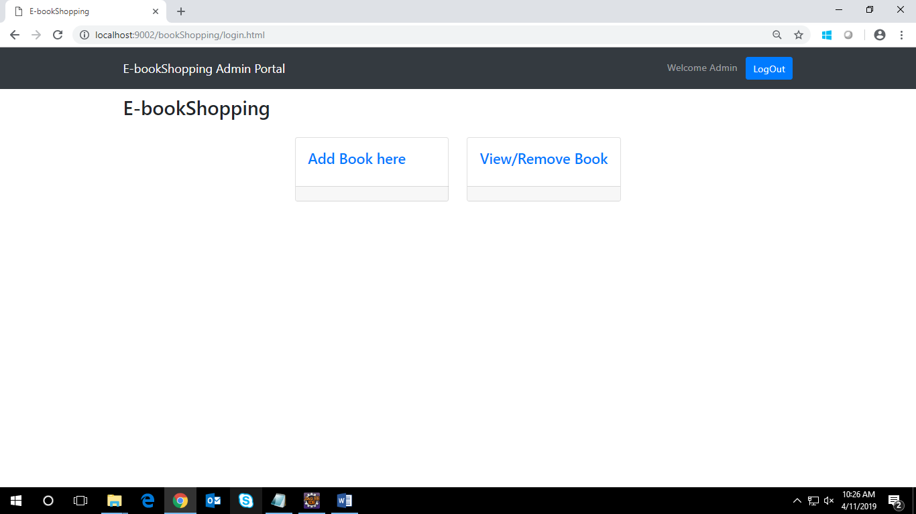

### Business Rules

Business rules should be defined using the following attributes: -

* When the user clicks on the ‘add book’ link, it should re-direct to page where details to be filled.
* Details of book to be filled as below in requirement: Category, Book Id, Book Name, Book Price, Availability, Binding, Language, Author Name, Publisher Name, Delivery Date.
* Clicking ‘add book’ button should add that book to the database which is accessed by user later.
* User is able to view details of book or remove book details from the database.
* Post-successful addition or deletion of book, save the information in the database.

### UI Requirements

Here is a prototype on how the admin home page should look like.

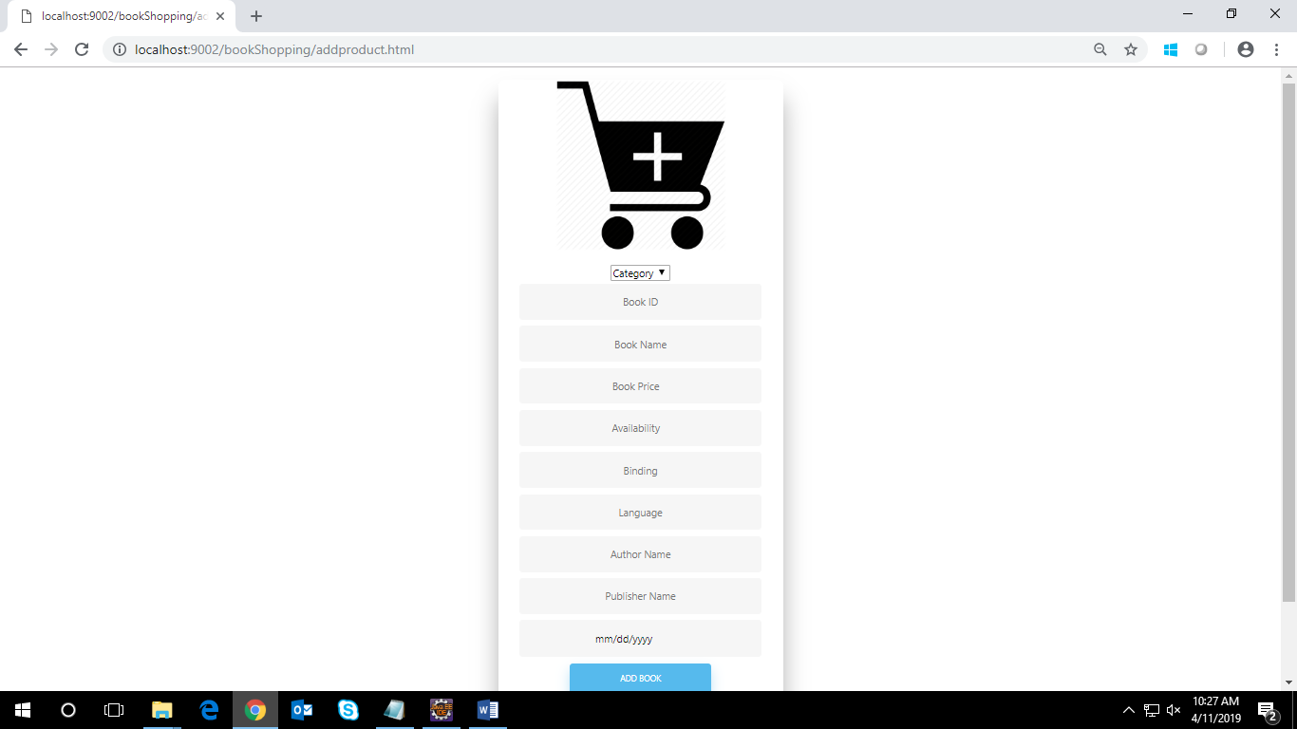

### UI Field Validations

Please refer to the below requirements for field level validations:

* All fields are mandatory.
* The price format must be checked.
* The availability format should be checked.

# Database Design

## Tables Structure

**User Registration Details:**

|  |  |  |  |
| --- | --- | --- | --- |
| **Column Name** | **Data Type** | **Length** | **Nulls** |
| firstName | varchar | 255 | N |
| lastName | varchar | 255 | N |
| age | varchar | 255 | N |
| gender | varchar | 255 | N |
| conatctNumber | varchar | 255 | N |
| emailId | varchar | 255 | N |
| password | varchar | 255 | N |

**User/Admin Login Details:**

|  |  |  |  |
| --- | --- | --- | --- |
| **Column Name** | **Data Type** | **Length** | **Nulls** |
| emailId | varchar | 255 | N |
| password | varchar | 255 | N |

**Book Details:**

|  |  |  |  |
| --- | --- | --- | --- |
| **Column Name** | **Data Type** | **Length** | **Nulls** |
| bookId | varchar | 255 | N |
| bookName | varchar | 255 | N |
| authorName | varchar | 255 | N |
| availability | varchar | 255 | N |
| binding | varchar | 255 | N |
| catName | varchar | 255 | N |
| DeliveryDate | datetime |  | N |

**Book Add to Cart Details:**

|  |  |  |  |
| --- | --- | --- | --- |
| **Column Name** | **Data Type** | **Length** | **Nulls** |
| cartId | int | 11 |  |
| bookName | varchar | 255 | N |
| price | varchar | 255 | N |
| userId | varchar | 255 | N |

# Data Flow Diagram

# C:\Users\768874\Desktop\final\DFD.jpg